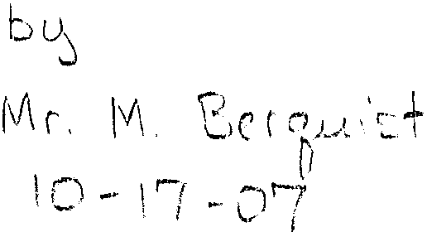ON THE S1GNIFICANCE OF CLOTHES

One does not usually dress up animals. But human beings universally wear clothes. What is the reason for this?

One explanation is that the disorders of our fallen nature require modest concealment, and this is true indeed, and has a decisive bearing on what should be worn on all occasions. But is this the entire explanation? Some go as far as to say that it does not matter what one wears, on any occasion, provided that the requirements of modesty be met.

Such a view seems plainly contrary to experience.. No one wears the same kind of clothing on all occasions. Of course, one might say that this variety is required by differences in the environment: heavier clothing in cold weather, lighter clothing in warm weather, different clothing for sleeping than for waking, and so on.

Nevertheless, such utilitarian considerations are not a sufticient explanation. In choosing clothes, one has regard to color and pattern, and to the occasions on which the clothes are to be worn. The exceptions are so rare as to be insignificant. There is general agreement that there are right clothes and wrong clothes for certain occasions. Disagreements concern what is appropriate for a given occasion and the significance and importance of that occasion.

The practice of the Church confirms this. There are particular vestments for the celebration of the Mass, which vary according to the season and the solemnity of the rites. Also, there are several components to these vestments --the alb, the stole, the maniple, the chasuble, each of which has its own significance. Religious orders, likewise, have traditionally worn distinctive habits, and it is no surprise that the contemporary abandonment of these habits has accompanied a loss of commitment to the ideals that define those orders. But this brings us to consider in general the significance of clothing in human life.

Since an interest in clothes is unique to human beings, the reason for this must lie in what distinguishes man from the other animals. Man lives by art and reason, the other animals by sensation and instinct. Instinct seems to be a sort of specific "know how," not grounded in understanding, limited to determinate acts appropriate to survival. For example, a spider weaves her web, a structure that enables her to survive and reproduce, but she does not know what a web is or why she is weaving it. Accordingly, she is limited to that particular instrument of life, and has organs that are suitable to that task alone. If she had other instruments, she would not know how to use them.

Man, on the other hand, has reason: he understands what he is doing and why he is doing it. Because he can see the proportion of means to ends, he is not limited to this or that specific operation, but can devise a variety of means for a variety of ends. Thus, his body is without the specialized organs found in the other animals. In place ofthese he has the hand -the tool of tools--- whereby he can make the tools tha1 he needs.
1hese tools are, as it were, completions of his substance. Nature, which is a principle determined to single effects, could not adequately provide man with organs suitable to special uses without making him incapable of the great variety of operations sufficient for human life. Likewise, nature has not given man a complete
exterior --he does not have fur or scales or feathers, or any other such special covering. Thus, he comes forth from the womb naked, deprived of his final covering. He completes his covering through one of his artifacts, clothes.

But further, since he knows what he is doing and why he is doing it, it is natural for him to signify, through outward signs, the meaning and importance of where he is and what he is doing. Thus, to ignore or omit this signification also makes a statement: that there is "nothing special." One signifies either respect or

lack of respect. Recall the parable about the man without a wedding garment Though the absence of sanctifYing grace is what is signified, the parable supposes that we understand that one does not go to a wedding without dressing in a way that recognizes and honors the dignity ofthe occasion.

There are many other examples of the significance, as well as the utility of clothing. Consider military clothes. Not only is there combat gear, suitable for battle, there are also dress uniforms. These indicate division, rank, campaigns served in, and honors received, among other things. (One could go on at length about decorations for valor. These signify the kinds and levels of honorable service in considerable detail, and honor is the suitable adornment of virtue.)

In summary, then, given man's composite nature, it is natural for him to signify what he understands. Accordingly, when he determines no/ to signify, even that signifies, usually disregard or contempt, though such may not be deliberately intended.

